Technology Stack

Frontend:
- React.js – For building the user interface.
- Redux – For state management.
- HTML, CSS, JavaScript – Core web technologies.
- Tailwind CSS – For styling and UI components.
- Axios – For API requests.
- React Router – For handling navigation.

Backend:
- Node.js – Server-side JavaScript runtime.
- Express.js – Web framework for Node.js.
- REST API – For handling data communication.

Third-Party Services:
- TMDB API – For fetching movie data.

Deployment Diagram
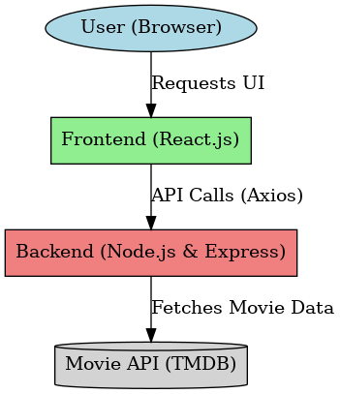
Component Diagram
